PostgreSQL Relational Structures

Task 1 — Performance with Unlogged Tables
Student: Yusuf Ziya Köse
Database: dwh
Schema: labs
Tool: PostgreSQL 18 / psql terminal
Topic: Logged table vs Unlogged table insert performance

1. Introduction
In this lab, I started working on PostgreSQL relational structures.
The first task was about comparing the insert performance of a normal PostgreSQL table and an UNLOGGED table.
At the beginning, I was not sure where I should write the SQL commands because I had PostgreSQL running from the PostgreSQL application window. After checking the environment, I used the Connect option and worked inside the psql terminal.
In this task, I used the dwh database instead of test_db, because this was the database available in my PostgreSQL environment.

2. Preparation
Before starting Task 1, I prepared the schema and the person table as required by the lab instructions.
First, I used the labs schema. Then I recreated the person table and inserted three sample rows.
sql
CREATE SCHEMA IF NOT EXISTS labs;

SET search_path TO labs, public;

DROP TABLE IF EXISTS labs.person CASCADE;

CREATE TABLE labs.person (
id integer NOT NULL,
name varchar(15)
);

INSERT INTO labs.person VALUES (1, 'Bob');
INSERT INTO labs.person VALUES (2, 'Alice');
INSERT INTO labs.person VALUES (3, 'Robert');

SELECT * FROM labs.person;
The result was:
id | name
---+--------
1 | Bob
2 | Alice
3 | Robert
This confirmed that the initial setup was completed successfully.

3. Task Goal
The goal of Task 1 was to compare insert performance between:
- A normal logged table
- An UNLOGGED table
A normal PostgreSQL table writes changes to WAL logs.
An UNLOGGED table does not write data changes to WAL in the same way, so insert operations can be faster.
However, UNLOGGED tables are not crash-safe. If the database server crashes, data in these tables may be lost.

4. Important Fix in the Lab Query
In the original lab document, the insert query was written like this:
sql
INSERT INTO test_simple VALUES (generate_series(1,1000000));
But the table has two columns:
a int,
b int
So inserting only one value would not match the table structure.
Because of this, I used this corrected version:
sql
INSERT INTO labs.test_simple(a, b)
SELECT gs, gs
FROM generate_series(1, 1000000) AS gs;
I used the same logic for both the normal table and the unlogged table.

5. Creating the Normal Table
First, I removed old test tables if they existed.
DROP TABLE IF EXISTS labs.test_simple;
DROP TABLE IF EXISTS labs.test_unlogged;
Then I created a normal logged table:
CREATE TABLE labs.test_simple (
a int,
b int
);
This table is a regular PostgreSQL table. It writes changes to WAL.

6. Insert Test on Normal Table
I inserted 1,000,000 rows into the normal table:
sql
INSERT INTO labs.test_simple(a, b)
SELECT gs, gs
FROM generate_series(1, 1000000) AS gs;
The insert time was:
text
1733.882 ms
This is approximately:
text
1.73 seconds
Then I checked the row count:
sql
SELECT count(*) FROM labs.test_simple;
The result was:
text
1000000
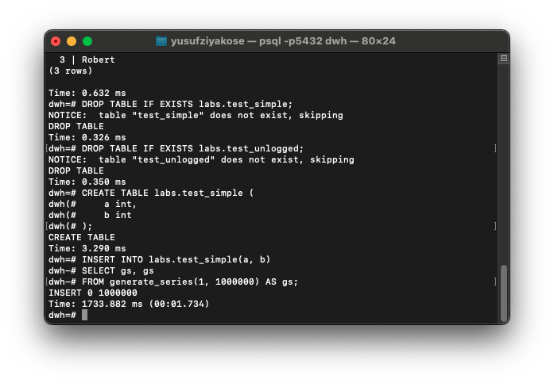
1,000,000 rows were inserted into the normal logged table in about 1.73 seconds.

Next, I inserted 5,000,000 more rows into the same table:
sql
INSERT INTO labs.test_simple(a, b)
SELECT gs, gs
FROM generate_series(1, 5000000) AS gs;
The insert time was:
text
7885.366 ms
This is approximately:
text
7.89 seconds
Then I checked the total row count:
sql
SELECT count(*) FROM labs.test_simple;
The result was:
text
6000000
The total became 6,000,000 because I inserted 1,000,000 rows first and then 5,000,000 more rows.

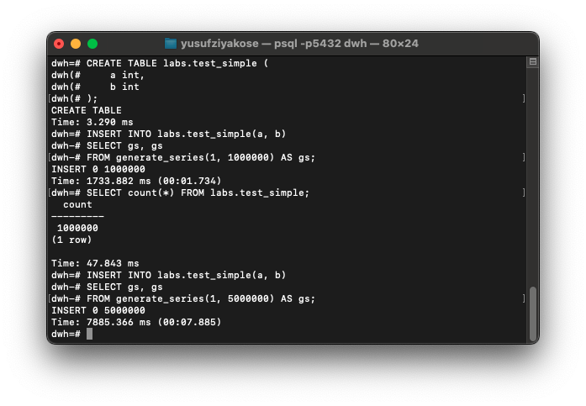After inserting 5,000,000 more rows, the normal table contained 6,000,000 rows in total.

7. Creating the Unlogged Table
After testing the normal table, I created an UNLOGGED table with the same structure.
sql
CREATE UNLOGGED TABLE labs.test_unlogged (
a int,
b int
);
This table has the same columns as test_simple, but it is not logged in the same way as a normal table.

8. Insert Test on Unlogged Table
I inserted 1,000,000 rows into the unlogged table:
sql
INSERT INTO labs.test_unlogged(a, b)
SELECT gs, gs
FROM generate_series(1, 1000000) AS gs;
The insert time was:
text
750.525 ms
This is approximately:
text
0.75 seconds
Then I checked the row count:
sql
SELECT count(*) FROM labs.test_unlogged;
The result was:
text
1000000

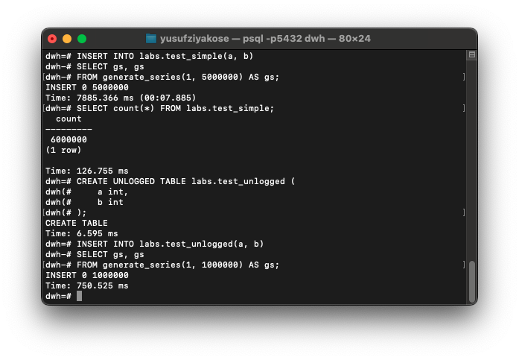
1,000,000 rows were inserted into the unlogged table in about 0.75 seconds.

Then I inserted 5,000,000 more rows into the unlogged table:
sql
INSERT INTO labs.test_unlogged(a, b)
SELECT gs, gs
FROM generate_series(1, 5000000) AS gs;
The insert time was:
text
3902.679 ms
This is approximately:
text
3.90 seconds
Then I checked the total row count:
sql
SELECT count(*) FROM labs.test_unlogged;
The result was:
text
6000000

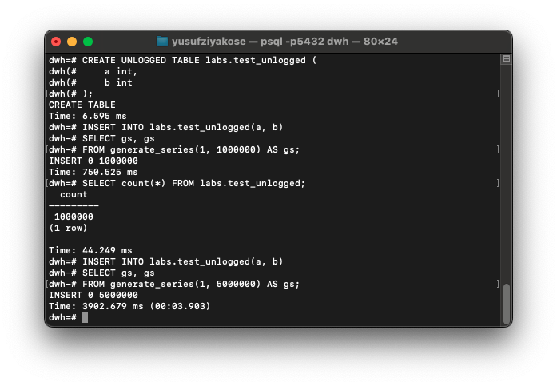
After inserting 5,000,000 more rows, the unlogged table also contained 6,000,000 rows in total.

9. Table Size Comparison
After both tables had 6,000,000 rows, I checked their sizes.
sql
SELECT
pg_size_pretty(pg_relation_size('labs.test_simple')) AS test_simple_size,
pg_size_pretty(pg_relation_size('labs.test_unlogged')) AS test_unlogged_size;
The result was:
text
test_simple_size | test_unlogged_size
-----------------+-------------------
207 MB | 207 MB
Both tables had the same size because they contained the same data.

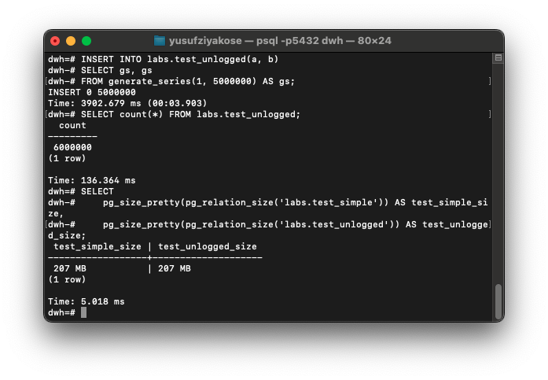
Both tables had the same final size because they contained the same number of rows and the same column structure.

10. Results
The final results were:
Table | Type | Inserted Rows | Time

labs.test_simple | Normal / logged | 1,000,000 | 1733.882 ms
labs.test_simple | Normal / logged | 5,000,000 | 7885.366 ms
labs.test_unlogged | Unlogged | 1,000,000 | 750.525 ms
labs.test_unlogged | Unlogged | 5,000,000 | 3902.679 ms
In seconds:
Table | Type | Inserted Rows | Time

labs.test_simple | Normal / logged | 1,000,000 | 1.73 s
labs.test_simple | Normal / logged | 5,000,000 | 7.89 s
labs.test_unlogged | Unlogged | 1,000,000 | 0.75 s
labs.test_unlogged | Unlogged | 5,000,000 | 3.90 s

11. My Observation
The UNLOGGED table was faster than the normal logged table.
For 1,000,000 rows:
text
Normal table: 1.73 seconds
Unlogged table: 0.75 seconds
For 5,000,000 rows:
text
Normal table: 7.89 seconds
Unlogged table: 3.90 seconds
So, in my test, the unlogged table was about two times faster.

12. Why Did This Happen?
Normal PostgreSQL tables write changes to WAL.
WAL means:
text
Write-Ahead Log
WAL is important because it helps PostgreSQL recover data after a crash.
However, writing to WAL creates extra disk work.
That is why inserting many rows into a normal table takes more time.
UNLOGGED tables do not write data changes to WAL in the same way.
Because of this, PostgreSQL does less write work, and insert operations become faster.

13. Why Were the Table Sizes the Same?
Both tables had:
text
6,000,000 rows
2 integer columns
So both tables used the same amount of storage:
text
207 MB
The performance difference does not come from the table size.
It comes from the logging behavior.
Normal table:
text
Data + WAL logging
Unlogged table:
text
Data, but less WAL logging

14. Disadvantage of Unlogged Tables
Even though unlogged tables are faster, they have an important disadvantage.
If the PostgreSQL server crashes, data in unlogged tables can be lost or cleared.
Because of this, unlogged tables should not be used for critical permanent data.
They are more suitable for:
- temporary ETL staging data
- intermediate processing tables
- data that can be regenerated
- large imports that can be repeated if needed

15. What I Learned
In this task, I learned that table type can affect insert performance.
Before doing the task, I knew that indexes could affect performance, but I did not fully understand that logging behavior could also make a big difference.
I also learned that:
- Normal tables are safer because they use WAL.
- Unlogged tables are faster for inserts.
- Unlogged tables are risky after a crash.
- Table size can stay the same even if performance is different.
- generate_series() is useful for creating large test data.
- In PostgreSQL, insert queries must match the number of table columns.

16. Difficulties I Had
At first, I had a few small difficulties.
The first one was about the PostgreSQL tool. I had PostgreSQL running, but I was not sure where I should write SQL commands. After checking the PostgreSQL application window, I used the Connect option and opened the psql terminal.
Another issue was in the original lab query. The table had two columns, but the example insert query inserted only one value. Because of this, I corrected the insert query by using:
sql
SELECT gs, gs
FROM generate_series(...)
This way, both columns a and b received values.
After these points were clear, the rest of the task was easy to follow.

17. Conclusion
This task showed that UNLOGGED tables can be much faster than normal logged tables for large insert operations.
In my test, the unlogged table inserted data almost two times faster than the normal table.
However, this speed comes with a trade-off: unlogged tables are not crash-safe.
For this reason, I would use unlogged tables only when the data is temporary, can be recreated, or is used as an intermediate ETL/staging table.

Yusuf Ziya Kose (yusufziya_kose@epam.com)

